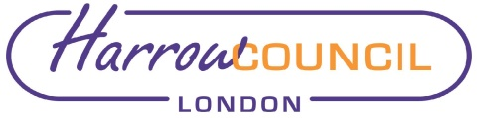
Report for: | NW London Joint Overview and Scrutiny Committee
Date of Meeting: | 14 December 2021
Subject: | Palliative Care Review
Responsible Officer: | n/a
Report author: | n/a
Enclosures: | Appendix A – Update for JHOSC  Appendix B - Issues Paper  Appendix C - Summary Issues Paper

Section 1 – Summary and Recommendations
This report sets out the focused piece of work that has commenced in North West London to improve the quality, equity and experience of community-based specialist palliative care and support residents and their family/ carers receive, as well as the sustainability of our services.

Recommendations:

No recommendations – for information only

